Child Protection Policy

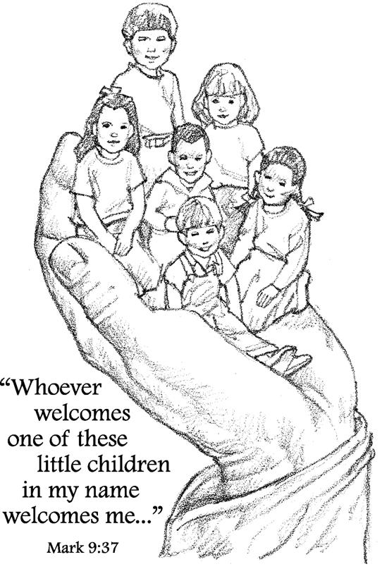
Our Purpose:

Our church considers children an integral part of the church. At all times we wish to safeguard all members of the church, whether children, leaders or the general church community. It is our aim to enable children, through contact with the church and with designated leaders, to learn about Jesus and be nurtured in their faith, free from concern about their personal and emotional safety. We will provide dedicated and conscientious leaders who will take all reasonable care of our children and accept that we have a duty to protect children in our care from abuse. We are a church dedicated to ministering to children and committed to being proactive in their safety and protecting the integrity of our adults. As a result, we submit the following standards of conduct at.

Definition of “children”

The term “child” or “children” shall include all children under the age of eighteen (18) years in the care of Discovery Bay International Community Church (DBICC).
Standards of Conduct

The goal of DBICC is to create a warm and caring environment for children to experience the love of Jesus. Common expressions of affection, affirmation, support, or physical caretaking are appropriate in this community of caring Christians. Care must be taken, however, that physical expressions of affection are appropriate for the age and are not excessive or imposed upon another individual. If a child seems uncomfortable with any such contact, the church leader should discontinue. If a young child needs to use the toilet but is unwilling to do so with a DBICC volunteer, parents should be asked to come and assist.

Selection and Screening Process for Volunteers

Volunteer applicants must complete and sign a Volunteering for Service Kids Community & Teens Discovery Bay Community Church Application.

Applications will be submitted to the Kids Community co-ordinator (KCC). The KCC will be responsible for meeting with the applicant, talking through the application questions and conducting reference checks. The church keeps confidential all information received in the applicant selection process. Such information will be stored with access afforded only to appropriate church staff on a need-to-know basis. If the church learns of false, misleading or amended information on an application that could cause potential danger to children or liability to the church, that person shall no longer be permitted to serve as a volunteer in Kids Community and teen ministry activities.

References

The KCC shall conduct an inquiry into the character of the applicant volunteer. References may be checked by phone, email or in person. References must include: a person who has known the applicant for 3 to 6 months minimum and preferably a referee known in the Discovery Bay community.

Information gained in these checks should be noted directly on the application by the person conducting the enquiry.

Employees and volunteers of the church must provide their HK ID or Passport no. to be used to conduct any further checks.

Minimum age

All Kids Church leaders must be 18 years of age or older. Younger persons may assist adults in a support capacity (eg: as a small group assistant or a buddy).

Three - Six-month rule
No volunteer will be allowed to work with children in any capacity until they have been an active participant of the church for a minimum of three (3) to six (6) months. The applicant must have been a regular attendee and involved in church activities for that period of time. This time of interaction between our leadership and the applicant allows for better evaluation and suitability of the applicant for working with children. Prior to completion of the 3-6 month minimum period, individuals are welcome to assist or observe in the classroom.

Supervision of Children

Parents are responsible for their own children at all times while attending church functions. All members of our congregation should show concern for a child who is unsupervised. So, during a church function, children should either be with their class or with their parent, and if not, the child will be directed to one or the other.

- Safety of children

It is the responsibility of all persons having contact with children participating in church programs to promote the emotional and physical safety of the participants giving regard to all factors and circumstances known to them. Nothing contained in any other church policy, procedure or instruction shall be construed to relieve persons having contact with children from this responsibility.

- ‘Junior Kids Church’ identification system

DBICC will have in place an identification system so that the adults who drop off a small child are the same adults who pick the child up, or approved by the parents to pick them up. The Junior Kids Church leader shall maintain the system to identify persons authorized to pick up and take responsibility for preschool children leaving a church activity. If their parent or guardian does not pick up a child in Junior Kids Church on time, he will be kept by his teachers in the classroom, where safe supervision can be continued, until the parent or guardian is located.

3. Two-adult rule

It shall be the goal of DBICC that at least two workers will be in attendance at all times when children are being supervised during a church activity regardless of the number of participants, location or activity. At least one of these must be the responsible leader. Where one of the leaders is required to undertake a duty with the children, the remaining adult should avoid being alone with one child.

4. Observation of children

At no time will a DBICC helper/leader schedule an activity with a child where no other adult/child is in attendance.
5. Cases of Child Abuse
See guidance notes in Appendix 1.

Appendix 1
Child discloses abuse by someone external to the church
Principles
It is important to listen to the child. Do not treat any suspicion as frivolous. The teacher’s role is not to investigate abuse and as such, the church will not be in a position to establish whether abuse has occurred, but the goal should be to support families to protect children. Hence, we are always talking about ‘alleged’ abuse. Bearing in mind that there is potential for errors due to language, interpretation and the child's skill level in expressing themselves it is helpful if you keep notes about what exactly the child says rather than elaborate or try to interpret what you think might have happened.

Steps to be Taken
Within the same day inform the KCC of the alleged abuse. The KCC and the leader to whom the alleged abuse has been reported will review and agree further action and if the pastor needs to be involved.
Do not speak to parents of the Child or the alleged abuser.

Ministerial care

The Pastor and KCC shall encourage and assist the Child and the parents in securing appropriate counselling, care and support. All persons shall act towards the Child, the parents and the accused in a Christ-like manner…speaking the truth in love.

Confidentiality

All reports of child abuse or neglect shall be held in absolute confidence.

